- Explain the working FRQI algorithm in my research proposal

- Is this below workflow diagram is correct ?
If it not please tell me the correct workflow
And please tell which algorithm is use in which step.
Workflow of research
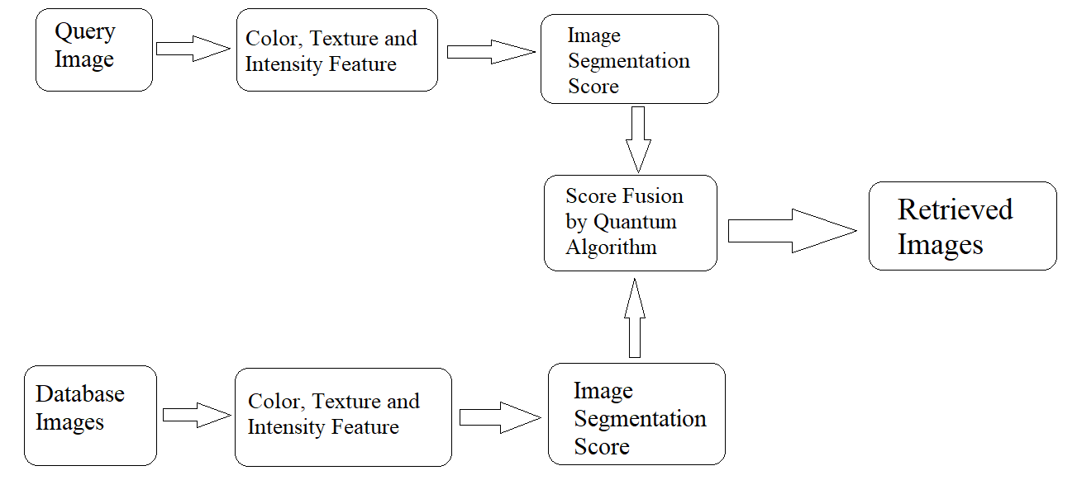
- First, all the images in the database are normalized. Then, Colour, Texture and intensity feature of each image of database is extracted and Image segmentation scores are assigned to each image.
- In second part i.e. query image part, Colour, Texture and intensity feature of the query image is extracted and Image segmentation scores are assigned .
- Now, these Image segmentation scores of Query image and Database image are compared by applying “Flexible Representation of Quantum Image” quantum Computational Technique and the images having similar scores as the query image are sent forward as output image or retrieved image.

