Home Page
Affordable Statistics & Research Methodology Services

One-on-one assistance from at affordable fees for statistics, research methodology with a professional approach. Prompt service delivery assured at all times.

- With you 24*7
- Highest quality guaranteed
- Strictly Confidential
- Nominal fee

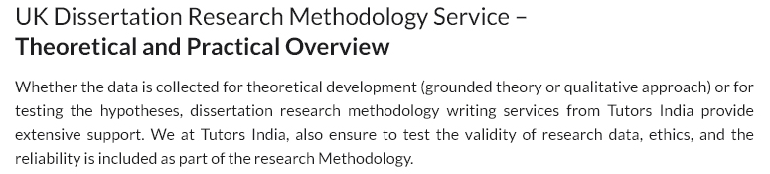

Statistician and Research Methodology Service
Overview of support & services

Statistics and research comprise of different methodologies like qualitative, quantitative, or triangulate. I have assisted hundreds of students across the globe in choosing the apt statistics and research methodology. I assure you that your research will be backed with correct statistical analysis, interpretation of the statistical data, and working on statistical tools. I ensure strict confidentiality, reliability, and quality are guaranteed.
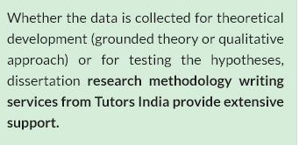

Share your details below for support on statistics and research methodology. You will save time and money both by hiring me to help you with your work.

- Methodology Consulting

I have assisted hundreds of research scholars from different fields. I take pride in the fact that I have successfully enabled my clients to submit quality research, dissertations, doctoral proposals, articles & journals, statistical assignments, projects, concept papers, and qualitative & quantitative data analysis. I am trusted by my clients for timely delivery, through research on a variety of areas, accurate analysis, and correct interpretation. My working style focuses on aiding clients with detailed statistical interpretation and not just a brief explanation of the raw data like other statisticians.

- My Guarantee

I guarantee the highest quality work at an affordable cost within the agreed time to all my clients. My experience has helped me understand the need for uniqueness of statistical data without compromising with the quality of the deliverable. I also charge a nominal fee for my services from my clients so that I can assist a larger number of clients. I assure my clients to always submit their deliverables on time committed. Ill-timed submission is a detriment, and this is why I provide a 100% guarantee to never delay the timelines agreed.

I have assisted my clients with statistical and research methodology on a wide range of topics. I work towards helping you with your data gathering, statistical analysis on raw data, interpretation, reporting, and final presentation.

- Software's I work on

I know-how of working on a wide variety of statistical software. I have assisted my clients with statistical and data analysis using SPSS, STATA, R, SAS, SmartPLS, NVivo, MINITAB, S-Plus, EViews, MPlus, and LISRE. I use software packages for all the major statistics and data analysis tools. In case you prefer a specific statistical software package, please let me know so that I can work on it for your report. I deliver statistical and data analysis for your research using the best software package to generate accurate results.

- Why should you work with me for statistics project

- Best statistical experts to support you 24*7
- Assistance with selection of research design
- Select and work on statistical tools
- Accurate statistical interpretation
- Review comments and edits duly addressed
- Detailed review of the research proposal
- Report writing and formatting according to style

- How you can pay me?

I charge an affordable fee from research scholars, academicians, and private researchers. I ensure that my services are easily accessible by many researchers. I offer services at a nominal rate as compared to other service providers in the industry. I also assure you to match with any industry-accepted quote which you get from other service providers.

I accept 50% as a down payment for most of my projects, except for urgent projects. You can make secure payments online through PayPal, which accepts all major credit cards, debit cards, and bank transfers. To make payment, below available is PayPal link , click on the appropriate currency or make payment to my PayPal account ______________. Once the payment is received, I will confirm the same to you.

In case of assistance for payments using PayPal, please connect with their customer service, they are very helpful.

- Confidentiality and security

I have come across a lot of clients who no longer had privy of their research and dissertation compromised. I understand how important it is to you that your statistical research report is unique. I take personal responsibility to ensure that all the research related to your project stays confidential. You have complete right and authority on your data and the subsequent interpretations made from it. When you chose to work with me, there will be no questions asked regard to you or the project purpose. You are need required to mention my contribution to your research work. I have experience in matters related to data privacy, electronic data security, and ethics. I secure your data on an encrypted drive to ensure confidentiality.
- My work samples

I have appended a preview of the samples of work completed for my clients. I am sure these samples will help you understand the effort I put into each deliverable to ensure the best quality for all my clients. I am confident these samples will help you make your mind in choosing my services quicker.

