Your license will expire in 22 days.

REGRESSION

/MISSING LISTWISE

/STATISTICS COEFF OUTS R ANOVA CHANGE

/CRITERIA=PIN(.05) POUT(.10)

/NOORIGIN

/DEPENDENT Syntacticlanguagescores

/METHOD=ENTER Deprivedenviroments_v2Chaoticenviroment_v2Poolivingcondit ions_v2

LowSESconditions_v2Timespentinschools /SCATTERPLOT=(*ZRESID ,*ZPRED)

/RESIDUALS DURBIN HISTOGRAM(ZRESID) NORMPROB(ZRESID).

Regression

Variables Entered/Removed ª

 | Variables | Variables
Model | Entered | Removed | Method
1 | Time spent | . | Enter
 | in schools,
 | LowSEScondit
 | ions_v2,
 | Deprivedenvi
 | roments_v2,
 | Chaoticenviro
 | ment_v2,
 | Poorlivingcon
 | ditions_v2^{b}

- Dependent Variable: Syntacticlanguagescores

- All requested variables entered.

Model Summary ^{b}

 |  |  |  |  |  |  |  | Change Statistics
 |  |  |  |  | Adjusted R |  | Std. Error of | R Square
Model | R |  | R Square |  | Square |  | the Estimate | Change | F Change
1 | . 284 ª |  | .081 |  | .017 |  | 1.927 | .081 | 1.262
 |  |  |  |  | Model Summary ^{b}
 |  | Change Statistics
 |  |  |  |  |  |  | Durbin-
Model | df1 |  | df2 |  | Sig. F Change |  | Watson
1 | 5 |  | 7 2 |  | .290 |  | 2.108

- Predictors: (Constant), Time spent in schools, LowSESconditions_v2, Deprivedenviroments_v2, Chaoticenviroment_v2, Poorlivingconditions_v2

- Dependent Variable: Syntacticlanguagescores

Page 1

ANOVAª

 |  | Sum of
Model |  | Squares |  | df | Mean Square | F | Sig.
1 | Regression | 23 | .442 | 5 | 4.688 | 1.262 | . 290 ^{b}
 | Residual | 267 | .430 | 7 2 | 3.714
 | Total | 290 | .872 | 7 7

- Dependent Variable: Syntacticlanguagescores

- Predictors: (Constant), Time spent in schools, LowSESconditions_v2, Deprivedenviroments_v2, Chaoticenviroment_v2, Poorlivingconditions_v2

Coefficientsª

 |  |  |  |  | Standardized
 |  | Unstandardized Coefficients |  |  | Coefficients
Model |  | B |  | Std. Error | Beta | t
1 | (Constant) | 7.187 |  | 1.039 |  | 6.916
 | Deprivedenviroments_v2 | 1.179 |  | .779 | .295 | 1.513
 | Chaoticenviroment_v2 | .632 |  | .835 | .145 | .757
 | Poorlivingconditions_v2 | -.115 |  | .999 | -.030 | - . 1 | 1 5
 | LowSESconditions_v2 | -.809 |  | .986 | -.209 | - . 8 | 2 0
 | Time spent in schools | -.005 |  | .006 | -.103 | - . 8 | 7 8

Coefficientsª

Model |  | Sig.
1 | (Constant) | .000
 | Deprivedenviroments_v2 | .135

Chaoticenviroment_v2 . 452

Poorlivingconditions_v2 . 909

LowSESconditions_v2 . 415

Time spent in schools . 383

a. Dependent Variable: Syntacticlanguagescores

Residuals Statisticsª

 | Minimum | Maximum | Mean | Std. Deviation | N
Predicted Value | 6.15 | 8.22 | 7.41 | .552 | 7 8
Residual | -3.052 | 6.033 | .000 | 1.864 | 7 8
Std. Predicted Value | -2.289 | 1.465 | .000 | 1.000 | 7 8
Std. Residual | -1.584 | 3.130 | .000 | .967 | 7 8

a. Dependent Variable: Syntacticlanguagescores

Page 2

Charts

Histogram

Dependent Variable: Syntacticlanguagescores
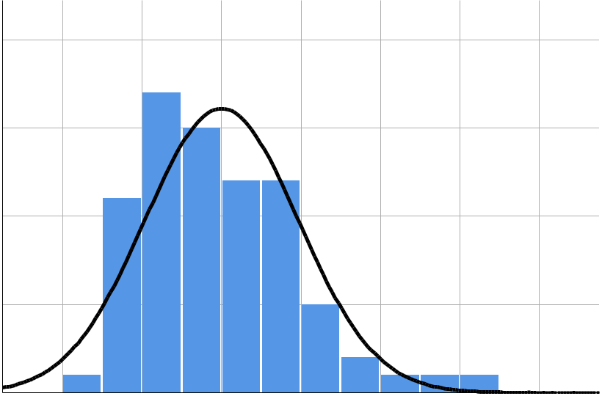

 |  |  |  |  |  |  | Mean = 8.59E-17
 | 2 0 |  |  |  |  |  | Std. Dev. = 0 . 9 6 7
 |  |  |  |  |  |  | N =78
 | 1 5
Frequency | 1 0
 | 5
 | 0
 | - 2 | - 1 | 0 | 1 | 2 | 3 | 4

Regression Standardized Residual

Normal P-P Plot of Regression Standardized Residual

Dependent Variable: Syntacticlanguagescores
1 . 0
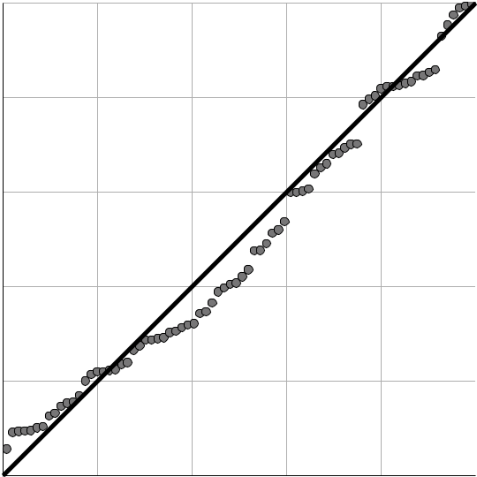

0 . 8

Expected Cum Prob

0 . 6

0 . 4

0 . 2

0 . 0
0.0 0.2 0.4 0.6 0.8 1.0

Observed Cum Prob

Page 3

Scatterplot

Dependent Variable: Syntacticlanguagescores
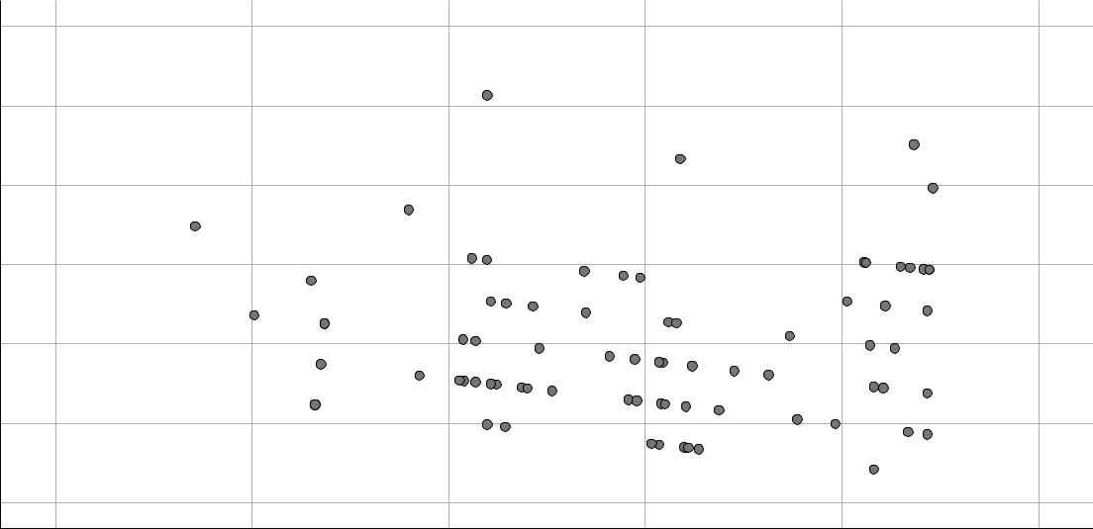

Regression Standardized Residual

4

3

2

1

0

- 1

- 2

-3 -2 -1 0 1 2

Regression Standardized Predicted Value

REGRESSION

/MISSING LISTWISE

/STATISTICS COEFF OUTS R ANOVA CHANGE

/CRITERIA=PIN(.05) POUT(.10)

/NOORIGIN

/DEPENDENT Syntacticlanguagescores

/METHOD=ENTER Deprivedenviroments_v2Chaoticenviroment_v2Poolivingcondit ions_v2

LowSESconditions_v2Timespentinschools /SCATTERPLOT=(*ZRESID ,*ZPRED)

/RESIDUALS DURBIN HISTOGRAM(ZRESID) NORMPROB(ZRESID)

/SAVE ZPRED COOK LEVER ZRESID.

Regression

Page 4

Variables Entered/Removed ª

 | Variables | Variables
Model | Entered | Removed | Method
1 | Time spent | . | Enter
 | in schools,
 | LowSEScondit
 | ions_v2,
 | Deprivedenvi
 | roments_v2,
 | Chaoticenviro
 | ment_v2,
 | Poorlivingcon
 | ditions_v2^{b}

- Dependent Variable: Syntacticlanguagescores

- All requested variables entered.

Model Summary ^{b}

 |  |  |  |  |  |  |  | Change Statistics
 |  |  |  |  | Adjusted R |  | Std. Error of | R Square
Model | R |  | R Square |  | Square |  | the Estimate | Change | F Change
1 | . 284 ª |  | .081 |  | .017 |  | 1.927 | .081 | 1.262
 |  |  |  |  | Model Summary ^{b}
 |  | Change Statistics
 |  |  |  |  |  |  | Durbin-
Model | df1 |  | df2 |  | Sig. F Change |  | Watson
1 | 5 |  | 7 2 |  | .290 |  | 2.108

- Predictors: (Constant), Time spent in schools, LowSESconditions_v2, Deprivedenviroments_v2, Chaoticenviroment_v2, Poorlivingconditions_v2

- Dependent Variable: Syntacticlanguagescores

ANOVAª

 |  | Sum of
Model |  | Squares |  | df | Mean Square | F | Sig.
1 | Regression | 23 | .442 | 5 | 4.688 | 1.262 | . 290 ^{b}
 | Residual | 267 | .430 | 7 2 | 3.714
 | Total | 290 | .872 | 7 7

- Dependent Variable: Syntacticlanguagescores

- Predictors: (Constant), Time spent in schools, LowSESconditions_v2, Deprivedenviroments_v2, Chaoticenviroment_v2, Poorlivingconditions_v2

Page 5

Coefficientsª

 |  |  |  |  | Standardized
 |  | Unstandardized Coefficients |  |  | Coefficients
Model |  | B |  | Std. Error | Beta | t
1 | (Constant) | 7.187 |  | 1.039 |  | 6.916
 | Deprivedenviroments_v2 | 1.179 |  | .779 | .295 | 1.513
 | Chaoticenviroment_v2 | .632 |  | .835 | .145 | .757
 | Poorlivingconditions_v2 | -.115 |  | .999 | -.030 | - . 1 | 1 5
 | LowSESconditions_v2 | -.809 |  | .986 | -.209 | - . 8 | 2 0
 | Time spent in schools | -.005 |  | .006 | -.103 | - . 8 | 7 8

Coefficientsª

Model |  | Sig.
1 | (Constant) | .000
 | Deprivedenviroments_v2 | .135

Chaoticenviroment_v2 . 452

Poorlivingconditions_v2 . 909

LowSESconditions_v2 . 415

Time spent in schools . 383

a. Dependent Variable: Syntacticlanguagescores

Residuals Statisticsª

 | Minimum | Maximum |  | Mean | Std. Deviation | N
Predicted Value | 6.15 |  | 8.22 | 7.41 | .552 | 7 8
Std. Predicted Value | -2.289 | 1 | .465 | .000 | 1.000 | 7 8
Standard Error of | .350 |  | .999 | .508 | .167 | 7 8
Predicted Value
Adjusted Predicted Value | 5.59 |  | 8.36 | 7.41 | .600 | 7 8
Residual | -3.052 | 6 | .033 | .000 | 1.864 | 7 8
Std. Residual | -1.584 | 3 | .130 | .000 | .967 | 7 8
Stud. Residual | -1.610 | 3 | .261 | .000 | 1.004 | 7 8
Deleted Residual | -3.364 | 6 | .546 | -.001 | 2.011 | 7 8
Stud. Deleted Residual | -1.629 | 3 | .507 | .006 | 1.023 | 7 8
Mahal. Distance | 1.546 | 19 | .695 | 4.936 | 4.408 | 7 8
Cook's Distance | .000 |  | .151 | .013 | .025 | 7 8
Centered Leverage Value | .020 |  | .256 | .064 | .057 | 7 8

a. Dependent Variable: Syntacticlanguagescores

Page 6

Charts

Histogram

Dependent Variable: Syntacticlanguagescores

 |  |  |  |  |  |  | Mean = 8.59E-17
 | 2 0 |  |  |  |  |  | Std. Dev. = 0 . 9 6 7
 |  |  |  |  |  |  | N =78
 | 1 5
Frequency | 1 0
 | 5
 | 0
 | - 2 | - 1 | 0 | 1 | 2 | 3 | 4

Regression Standardized Residual

Normal P-P Plot of Regression Standardized Residual

Dependent Variable: Syntacticlanguagescores
1 . 0

0 . 8

Expected Cum Prob

0 . 6

0 . 4

0 . 2

0 . 0
0.0 0.2 0.4 0.6 0.8 1.0

Observed Cum Prob

Page 7

Scatterplot

Dependent Variable: Syntacticlanguagescores

Regression Standardized Residual

4

3

2

1

0

- 1

- 2

-3 -2 -1 0 1 2

Regression Standardized Predicted Value

GRAPH

/SCATTERPLOT(BIVAR)=ZPR_12 WITH ZRE_12

/MISSING=LISTWISE.

Graph
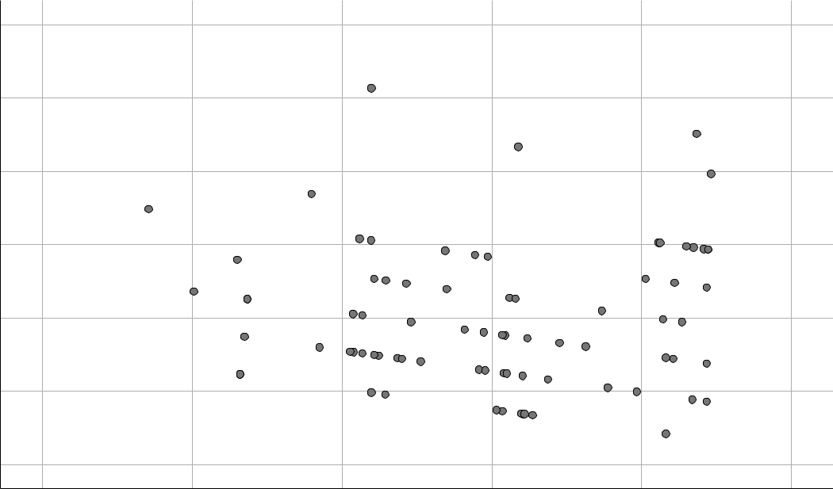

Standardized Residual

4.00000

3.00000

2.00000

1.00000

.00000

-1.00000

-2.00000

-3.00000 -2.00000 -1.00000 .00000 1.00000 2.00000

Standardized Predicted Value

REGRESSION

Page 8

/DESCRIPTIVES MEAN STDDEV CORR SIG N

/MISSING LISTWISE

/STATISTICS COEFF OUTS BCOV R ANOVA COLLIN TOL /CRITERIA=PIN(.05) POUT(.10) /NOORIGIN

/DEPENDENT Syntacticlanguagescores

/METHOD=ENTER Deprivedenviroments_v2Chaoticenviroment_v2Poolivingcondit ions_v2

LowSESconditions_v2Timespentinschools /SCATTERPLOT=(*ZRESID ,*ZPRED)

/RESIDUALS HISTOGRAM(ZRESID) NORMPROB(ZRESID).

Regression

Descriptive Statistics

 | Mean |  | Std. Deviation |  | N
Syntacticlanguagescores | 7 | . 41 | 1 | .944 | 7 8
Deprivedenviroments_v2 |  | . 63 |  | .486 | 7 8
Chaoticenviroment_v2 |  | . 27 |  | .446 | 7 8
Poorlivingconditions_v2 |  | . 46 |  | .502 | 7 8
LowSESconditions_v2 |  | . 47 |  | .503 | 7 8
Time spent in schools | 46 | .68 | 37 | .467 | 7 8

Correlations

 |  | Syntacticlangu | Deprivedenvir | Chaoticenviro
 |  | agescores | oments_v2 | ment_v2
Pearson Correlation | Syntacticlanguagescores | 1.000 | .191 | -.129
 | Deprivedenviroments_v2 | .191 | 1.000 | -.789
 | Chaoticenviroment_v2 | -.129 | -.789 | 1.000
 | Poorlivingconditions_v2 | .190 | .180 | -.214
 | LowSESconditions_v2 | -.175 | -.013 | .118
 | Time spent in schools | -.116 | -.126 | .222
Sig. (1-tailed) | Syntacticlanguagescores | . | .047 | .130
 | Deprivedenviroments_v2 | .047 | . | .000
 | Chaoticenviroment_v2 | .130 | .000 | .
 | Poorlivingconditions_v2 | .048 | .057 | .030
 | LowSESconditions_v2 | .062 | .455 | .152
 | Time spent in schools | .157 | .137 | .025
N | Syntacticlanguagescores | 7 8 | 7 8 | 7 8
 | Deprivedenviroments_v2 | 7 8 | 7 8 | 7 8
 | Chaoticenviroment_v2 | 7 8 | 7 8 | 7 8
 | Poorlivingconditions_v2 | 7 8 | 7 8 | 7 8

Page 9

Correlations

 |  | Poorlivingcondi | LowSESconditio | Time spent in
 |  | tions_v2 | ns_v2 | schools
Pearson Correlation | Syntacticlanguagescores | .190 | -.175 | -.116
 | Deprivedenviroments_v2 | .180 | -.013 | -.126
 | Chaoticenviroment_v2 | -.214 | .118 | .222
 | Poorlivingconditions_v2 | 1.000 | -.879 | -.128
 | LowSESconditions_v2 | -.879 | 1.000 | .054
 | Time spent in schools | -.128 | .054 | 1.000
Sig. (1-tailed) | Syntacticlanguagescores | .048 | .062 | .157
 | Deprivedenviroments_v2 | .057 | .455 | .137
 | Chaoticenviroment_v2 | .030 | .152 | .025
 | Poorlivingconditions_v2 | . | .000 | .132
 | LowSESconditions_v2 | .000 | . | .320
 | Time spent in schools | .132 | .320 | .
N | Syntacticlanguagescores | 7 8 | 7 8 | 7 8
 | Deprivedenviroments_v2 | 7 8 | 7 8 | 7 8
 | Chaoticenviroment_v2 | 7 8 | 7 8 | 7 8
 | Poorlivingconditions_v2 | 7 8 | 7 8 | 7 8
 | Correlations
 |  | Syntacticlangu | Deprivedenvir | Chaoticenviro
 |  | agescores | oments_v2 | ment_v2
 | LowSESconditions_v2 | 7 8 | 7 8 | 7 8
 | Time spent in schools | 7 8 | 7 8 | 7 8
 | Correlations
 |  | Poorlivingcondi | LowSESconditio | Time spent in
 |  | tions_v2 | ns_v2 | schools
 | LowSESconditions_v2 | 7 8 | 7 8 | 7 8
 | Time spent in schools | 7 8 | 7 8 | 7 8

Page 10

Variables Entered/Removed ª

 | Variables | Variables
Model | Entered | Removed | Method
1 | Time spent | . | Enter
 | in schools,
 | LowSEScondit
 | ions_v2,
 | Deprivedenvi
 | roments_v2,
 | Chaoticenviro
 | ment_v2,
 | Poorlivingcon
 | ditions_v2^{b}

- Dependent Variable: Syntacticlanguagescores

- All requested variables entered.

Model Summary ^{b}

 |  |  | Adjusted R | Std. Error of
Model | R | R Square | Square | the Estimate
1 | . 284 ª | .081 | .017 | 1.927

- Predictors: (Constant), Time spent in schools, LowSESconditions_v2, Deprivedenviroments_v2, Chaoticenviroment_v2, Poorlivingconditions_v2

- Dependent Variable: Syntacticlanguagescores

ANOVAª

 |  | Sum of
Model |  | Squares |  | df | Mean Square | F | Sig.
1 | Regression | 23 | .442 | 5 | 4.688 | 1.262 | . 290 ^{b}
 | Residual | 267 | .430 | 7 2 | 3.714
 | Total | 290 | .872 | 7 7

- Dependent Variable: Syntacticlanguagescores

- Predictors: (Constant), Time spent in schools, LowSESconditions_v2, Deprivedenviroments_v2, Chaoticenviroment_v2, Poorlivingconditions_v2

Page 11

Coefficientsª

 |  |  |  |  |  |  |  | Standardized
 |  | Unstandardized Coefficients |  |  |  |  |  |  | Coefficients
Model |  | B |  |  | Std. Error |  |  |  |  | Beta | t
1 | (Constant) | 7.187 |  |  | 1.039 |  |  |  |  |  | 6.916
 | Deprivedenviroments_v2 | 1.179 |  |  |  | .779 |  |  | .295 |  | 1.513
 | Chaoticenviroment_v2 | .632 |  |  |  | .835 |  |  | .145 |  | .757
 | Poorlivingconditions_v2 | -.115 |  |  |  | .999 |  |  | -.030 |  | -.115
 | LowSESconditions_v2 | -.809 |  |  |  | .986 |  |  | -.209 |  | -.820
 | Time spent in schools | -.005 |  |  |  | .006 |  |  | -.103 |  | -.878
 |  | Coefficientsª
 |  |  |  | Collinearity Statistics
Model |  | Sig. |  | Tolerance |  |  | VIF
1 | (Constant) | .000
 | Deprivedenviroments_v2 | .135 |  | .336 |  |  | 2.980
 | Chaoticenviroment_v2 | .452 |  | .347 |  |  | 2.879
 | Poorlivingconditions_v2 | .909 |  | .192 |  |  | 5.212
 | LowSESconditions_v2 | .415 |  | .196 |  |  | 5.094
 | Time spent in schools | .383 |  | .921 |  |  | 1.086

a. Dependent Variable: Syntacticlanguagescores

Coefficient Correlations ª

 |  |  | Time spent in | LowSESconditio | Deprivedenvir
Model |  |  | schools | ns_v2 | oments_v2
1 | Correlations | Time spent in schools | 1.000 | .131 | -.121
 |  | LowSESconditions_v2 | .131 | 1.000 | -.323
 |  | Deprivedenviroments_v2 | -.121 | -.323 | 1.000
 |  | Chaoticenviroment_v2 | -.209 | -.177 | .784
 |  | Poorlivingconditions_v2 | .156 | .893 | -.299
 | Covariances | Time spent in schools | 3.730E-5 | .001 | -.001
 |  | LowSESconditions_v2 | .001 | .973 | -.248
 |  | Deprivedenviroments_v2 | -.001 | -.248 | .608
 |  | Chaoticenviroment_v2 | -.001 | -.146 | .510
 |  | Poorlivingconditions_v2 | .001 | .880 | -.233

Page 12

Coefficient Correlations ª

 |  |  | Chaoticenviro | Poorlivingcondi
Model |  |  | ment_v2 | tions_v2
1 | Correlations | Time spent in schools | -.209 | .156
 |  | LowSESconditions_v2 | -.177 | .893
 |  | Deprivedenviroments_v2 | .784 | -.299
 |  | Chaoticenviroment_v2 | 1.000 | -.114
 |  | Poorlivingconditions_v2 | -.114 | 1.000
 | Covariances | Time spent in schools | -.001 | .001
 |  | LowSESconditions_v2 | -.146 | .880
 |  | Deprivedenviroments_v2 | .510 | -.233
 |  | Chaoticenviroment_v2 | .697 | -.095
 |  | Poorlivingconditions_v2 | -.095 | .999

a. Dependent Variable: Syntacticlanguagescores

Collinearity Diagnostics ª

 |  |  |  |  |  | Variance Proportions
 |  |  | Condition |  |  | Deprivedenvir |  | Chaoticenviro
Model | Dimension | Eigenvalue | Index |  | (Constant) | oments_v2 |  | ment_v2
1 | 1 | 3.575 | 1 | .000 | . 00 | . 01 |  | . 01
 | 2 | 1.176 | 1 | .744 | . 00 | . 02 |  | . 08
 | 3 | .851 | 2 | .050 | . 00 | . 02 |  | . 09
 | 4 | .305 | 3 | .425 | . 01 | . 00 |  | . 07
 | 5 | .065 | 7 | .409 | . 07 | . 94 |  | . 72
 | 6 | .028 | 11 | .322 | . 92 | . 01 |  | . 04

Collinearity Diagnostics ª

 |  | Variance Proportions
 |  | Poorlivingcondi | LowSESconditio | Time spent in
Model | Dimension | tions_v2 | ns_v2 | schools
1 | 1 | . 00 | . 00 | . 02
 | 2 | . 03 | . 02 | . 00
 | 3 | . 03 | . 04 | . 00
 | 4 | . 01 | . 02 | . 90
 | 5 | . 16 | . 19 | . 01
 | 6 | . 77 | . 73 | . 07

a. Dependent Variable: Syntacticlanguagescores

Page 13

Residuals Statisticsª

 | Minimum | Maximum | Mean | Std. Deviation | N
Predicted Value | 6.15 | 8.22 | 7.41 | .552 | 7 8
Residual | -3.052 | 6.033 | .000 | 1.864 | 7 8
Std. Predicted Value | -2.289 | 1.465 | .000 | 1.000 | 7 8
Std. Residual | -1.584 | 3.130 | .000 | .967 | 7 8

a. Dependent Variable: Syntacticlanguagescores

Charts

Histogram

Dependent Variable: Syntacticlanguagescores
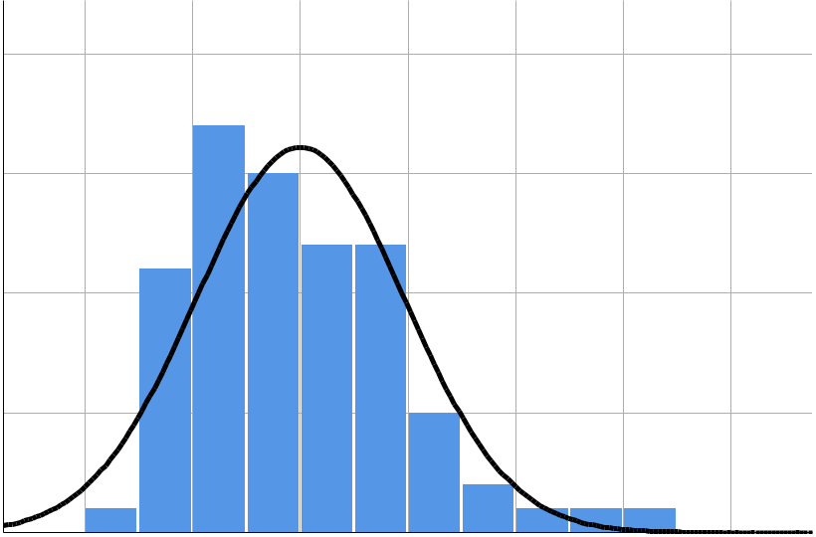

 |  |  |  |  |  |  | Mean = 8.59E-17
 | 2 0 |  |  |  |  |  | Std. Dev. = 0 . 9 6 7
 |  |  |  |  |  |  | N =78
 | 1 5
Frequency | 1 0
 | 5
 | 0
 | - 2 | - 1 | 0 | 1 | 2 | 3 | 4

Regression Standardized Residual

Page 14

Regression Standardized Residual

Normal P-P Plot of Regression Standardized Residual

Dependent Variable: Syntacticlanguagescores

 | 1 . 0
 | 0 . 8
Prob | 0 . 6
Cum
Expected | 0 . 4
 | 0 . 2
 | 0 . 0
 | 0 . 0 | 0 . 2 | 0 . 4 | 0 . 6 | 0 . 8 | 1 . 0

Observed Cum Prob

Scatterplot

Dependent Variable: Syntacticlanguagescores
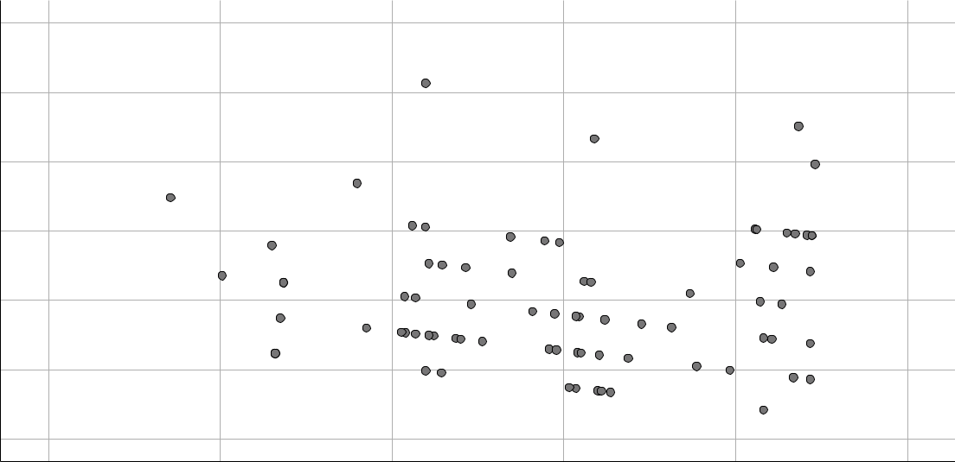

4

3

2

1

0

- 1

- 2

-3 -2 -1 0 1 2

Regression Standardized Predicted Value

Page 15

