REGRESSION

/MISSING LISTWISE

/STATISTICS COEFF OUTS R ANOVA COLLIN TOL CHANGE /CRITERIA=PIN(.05) POUT(.10) /NOORIGIN

/DEPENDENT TotalLanguagescores19QPre_regandReganalysis

/METHOD=ENTER Deprivedenviroments_v2Chaoticenviroment_v2Poolivingcondit ions_v2

LowSESconditions_v2Timespentinschools /SCATTERPLOT=(*ZRESID ,*ZPRED)

/RESIDUALS DURBIN HISTOGRAM(ZRESID) NORMPROB(ZRESID).

Regression

Variables Entered/Removed ª

 | Variables | Variables
Model | Entered | Removed | Method
1 | Time spent | . | Enter
 | in schools,
 | LowSEScondit
 | ions_v2,
 | Deprivedenvi
 | roments_v2,
 | Chaoticenviro
 | ment_v2,
 | Poorlivingcon
 | ditions_v2^{b}

- Dependent Variable: Total Language scores 19Q Pre-reg and Reg analysis

- All requested variables entered.

Model Summary ^{b}

 |  |  |  |  |  |  |  | Change Statistics
 |  |  |  |  | Adjusted R |  | Std. Error of | R Square
Model | R |  | R Square |  | Square |  | the Estimate | Change | F Change
1 | . 394 ª |  | .155 |  | .096 |  | 3.138 | .155 | 2.643
 |  |  |  |  | Model Summary ^{b}
 |  | Change Statistics
 |  |  |  |  |  |  | Durbin-
Model | df1 |  | df2 |  | Sig. F Change |  | Watson
1 | 5 |  | 7 2 |  | .030 |  | 2.040

- Predictors: (Constant), Time spent in schools, LowSESconditions_v2, Deprivedenviroments_v2, Chaoticenviroment_v2, Poorlivingconditions_v2

- Dependent Variable: Total Language scores 19Q Pre-reg and Reg analysis

Page 1

ANOVAª

 |  | Sum of
Model |  | Squares | df | Mean Square |  | F | Sig.
1 | Regression | 130.114 | 5 | 26 | .023 | 2.643 | . 030 ^{b}
 | Residual | 708.873 | 7 2 | 9 | .845
 | Total | 838.987 | 7 7

- Dependent Variable: Total Language scores 19Q Pre-reg and Reg analysis

- Predictors: (Constant), Time spent in schools, LowSESconditions_v2, Deprivedenviroments_v2, Chaoticenviroment_v2, Poorlivingconditions_v2

Coefficientsª

 |  |  |  |  |  |  |  |  |  |  | Standardized
 |  |  | Unstandardized Coefficients |  |  |  |  |  |  |  | Coefficients
Model |  |  | B |  |  |  | Std. Error |  |  |  |  | Beta |  |  |  | t
1 | (Constant) |  | 19.311 |  |  |  | 1.692 |  |  |  |  |  |  |  | 11.414
 | Deprivedenviroments_v2 |  | 2.875 |  |  |  | 1.269 |  |  |  | .424 |  |  |  | 2.265
 | Chaoticenviroment_v2 |  | .613 |  |  |  | 1.359 |  |  |  | .083 |  |  |  | .451
 | Poorlivingconditions_v2 |  | -2.693 |  |  |  | 1.627 |  |  |  | -.409 |  |  |  | -1.655
 | LowSESconditions_v2 |  | -2.768 |  |  |  | 1.606 |  |  |  | -.421 |  |  |  | -1.724
 | Time spent in schools |  | -.016 |  |  |  |  | .010 |  |  | -.180 |  |  |  | -1.591
 |  |  | Coefficientsª
 |  |  |  |  |  | Collinearity Statistics
Model |  |  | Sig. |  |  | Tolerance |  |  | VIF
1 | (Constant) |  | .000
 | Deprivedenviroments_v2 |  | .027 |  |  | .336 |  |  | 2.980
 | Chaoticenviroment_v2 |  | .653 |  |  | .347 |  |  | 2.879
 | Poorlivingconditions_v2 |  | .102 |  |  | .192 |  |  | 5.212
 | LowSESconditions_v2 |  | .089 |  |  | .196 |  |  | 5.094
 | Time spent in schools |  | .116 |  |  | .921 |  |  | 1.086
a. Dependent Variable: Total Language scores 19Q Pre-reg and Reg analysis
 |  | Residuals Statisticsª
 |  | Minimum | Maximum |  |  |  | Mean |  | Std. Deviation |  |  |  |  | N
Predicted Value |  | 15.49 | 19.40 |  |  | 17.99 |  |  |  |  | 1.300 |  |  | 7 8
Residual |  | -6.101 | 7.603 |  |  | .000 |  |  |  |  | 3.034 |  |  | 7 8
Std. Predicted Value |  | -1.920 | 1.085 |  |  | .000 |  |  |  |  | 1.000 |  |  | 7 8
Std. Residual |  | -1.944 | 2.423 |  |  | .000 |  |  |  |  | .967 |  |  | 7 8

a. Dependent Variable: Total Language scores 19Q Pre-reg and Reg analysis

Page 2

Charts

Histogram

Dependent Variable: Total Language scores 19Q Pre-reg and Reg analysis
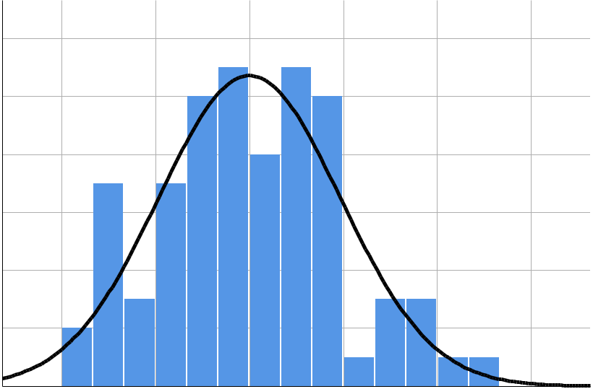

 |  |  |  |  |  | Mean = 1.51E-15
 | 1 2 |  |  |  |  | Std. Dev. = 0 . 9 6 7
 |  |  |  |  |  | N =78
 | 1 0
Frequency | 8
 | 6
 | 4
 | 2
 | 0
 | - 2 | - 1 | 0 | 1 | 2 | 3

Regression Standardized Residual

Normal P-P Plot of Regression Standardized Residual

Dependent Variable: Total Language scores 19Q Pre-reg and Reg analysis
1 . 0
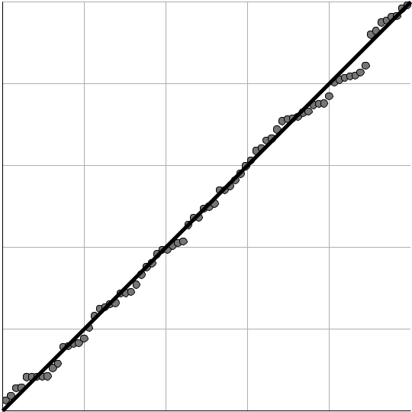

0 . 8

Expected Cum Prob

0 . 6

0 . 4

0 . 2

0 . 0
0.0 0.2 0.4 0.6 0.8 1.0

Observed Cum Prob

Page 3

Scatterplot

Dependent Variable: Total Language scores 19Q Pre-reg and Reg analysis
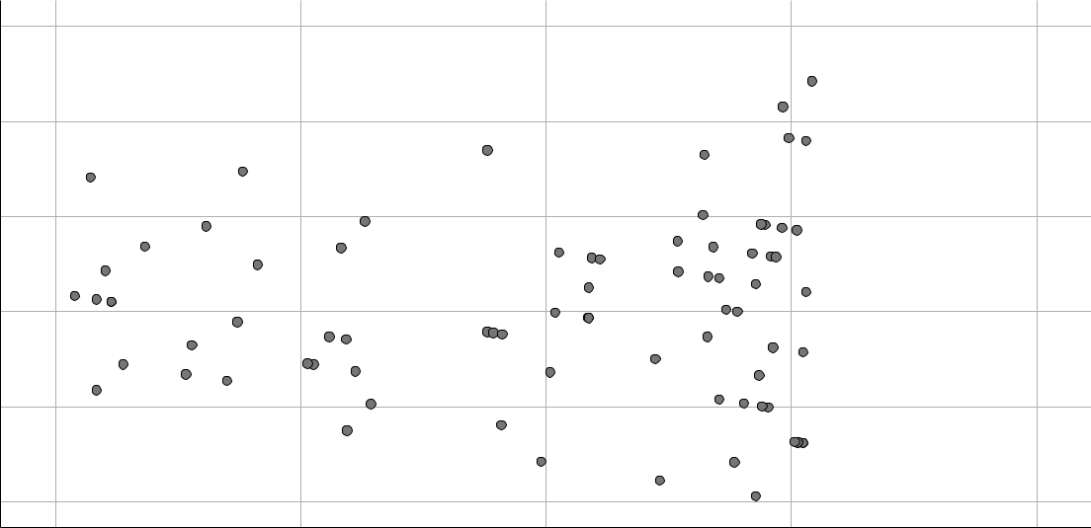

Regression Standardized Residual

3

2

1

0

- 1

- 2

-2 -1 0 1 2

Regression Standardized Predicted Value

REGRESSION

/MISSING LISTWISE

/STATISTICS COEFF OUTS R ANOVA COLLIN TOL CHANGE /CRITERIA=PIN(.05) POUT(.10) /NOORIGIN

/DEPENDENT TotalLanguagescores19QPre_regandReganalysis

/METHOD=ENTER Deprivedenviroments_v2Chaoticenviroment_v2Poolivingcondit ions_v2

LowSESconditions_v2Timespentinschools /SCATTERPLOT=(*ZRESID ,*ZPRED)

/RESIDUALS DURBIN HISTOGRAM(ZRESID) NORMPROB(ZRESID)

/SAVE ZPRED COOK LEVER ZRESID.

Regression

Page 4

Variables Entered/Removed ª

 | Variables | Variables
Model | Entered | Removed | Method
1 | Time spent | . | Enter
 | in schools,
 | LowSEScondit
 | ions_v2,
 | Deprivedenvi
 | roments_v2,
 | Chaoticenviro
 | ment_v2,
 | Poorlivingcon
 | ditions_v2^{b}

- Dependent Variable: Total Language scores 19Q Pre-reg and Reg analysis

- All requested variables entered.

Model Summary ^{b}

 |  |  |  |  |  |  |  | Change Statistics
 |  |  |  |  | Adjusted R |  | Std. Error of | R Square
Model | R |  | R Square |  | Square |  | the Estimate | Change | F Change
1 | . 394 ª |  | .155 |  | .096 |  | 3.138 | .155 | 2.643
 |  |  |  |  | Model Summary ^{b}
 |  | Change Statistics
 |  |  |  |  |  |  | Durbin-
Model | df1 |  | df2 |  | Sig. F Change |  | Watson
1 | 5 |  | 7 2 |  | .030 |  | 2.040

- Predictors: (Constant), Time spent in schools, LowSESconditions_v2, Deprivedenviroments_v2, Chaoticenviroment_v2, Poorlivingconditions_v2

- Dependent Variable: Total Language scores 19Q Pre-reg and Reg analysis

ANOVAª

 |  | Sum of
Model |  | Squares | df | Mean Square |  | F | Sig.
1 | Regression | 130.114 | 5 | 26 | .023 | 2.643 | . 030 ^{b}
 | Residual | 708.873 | 7 2 | 9 | .845
 | Total | 838.987 | 7 7

- Dependent Variable: Total Language scores 19Q Pre-reg and Reg analysis

- Predictors: (Constant), Time spent in schools, LowSESconditions_v2, Deprivedenviroments_v2, Chaoticenviroment_v2, Poorlivingconditions_v2

Page 5

Coefficientsª

 |  |  |  |  |  |  |  | Standardized
 |  | Unstandardized Coefficients |  |  |  |  |  |  | Coefficients
Model |  | B |  |  | Std. Error |  |  |  |  | Beta | t
1 | (Constant) | 19.311 |  |  | 1.692 |  |  |  |  |  | 11.414
 | Deprivedenviroments_v2 | 2.875 |  |  | 1.269 |  |  |  | .424 |  | 2.265
 | Chaoticenviroment_v2 | .613 |  |  | 1.359 |  |  |  | .083 |  | .451
 | Poorlivingconditions_v2 | -2.693 |  |  | 1.627 |  |  |  | -.409 |  | -1.655
 | LowSESconditions_v2 | -2.768 |  |  | 1.606 |  |  |  | -.421 |  | -1.724
 | Time spent in schools | -.016 |  |  |  | .010 |  |  | -.180 |  | -1.591
 |  | Coefficientsª
 |  |  |  | Collinearity Statistics
Model |  | Sig. |  | Tolerance |  |  | VIF
1 | (Constant) | .000
 | Deprivedenviroments_v2 | .027 |  | .336 |  |  | 2.980
 | Chaoticenviroment_v2 | .653 |  | .347 |  |  | 2.879
 | Poorlivingconditions_v2 | .102 |  | .192 |  |  | 5.212
 | LowSESconditions_v2 | .089 |  | .196 |  |  | 5.094
 | Time spent in schools | .116 |  | .921 |  |  | 1.086

a. Dependent Variable: Total Language scores 19Q Pre-reg and Reg analysis

Residuals Statisticsª

 | Minimum | Maximum |  | Mean | Std. Deviation | N
Predicted Value | 15.49 | 19.40 |  | 17.99 | 1.300 | 7 8
Std. Predicted Value | -1.920 | 1 | .085 | .000 | 1.000 | 7 8
Standard Error of | .569 | 1 | .626 | .827 | .271 | 7 8
Predicted Value
Adjusted Predicted Value | 15.21 | 20.16 |  | 17.99 | 1.329 | 7 8
Residual | -6.101 | 7 | .603 | .000 | 3.034 | 7 8
Std. Residual | -1.944 | 2 | .423 | .000 | .967 | 7 8
Stud. Residual | -1.987 | 2 | .480 | -.001 | .999 | 7 8
Deleted Residual | -6.374 | 7 | .963 | -.007 | 3.246 | 7 8
Stud. Deleted Residual | -2.030 | 2 | .575 | .001 | 1.011 | 7 8
Mahal. Distance | 1.546 | 19 | .695 | 4.936 | 4.408 | 7 8
Cook's Distance | .000 |  | .086 | .012 | .016 | 7 8
Centered Leverage Value | .020 |  | .256 | .064 | .057 | 7 8

a. Dependent Variable: Total Language scores 19Q Pre-reg and Reg analysis

Page 6

Charts

Histogram

Dependent Variable: Total Language scores 19Q Pre-reg and Reg analysis

 |  |  |  |  |  | Mean = 1.51E-15
 | 1 2 |  |  |  |  | Std. Dev. = 0 . 9 6 7
 |  |  |  |  |  | N =78
 | 1 0
Frequency | 8
 | 6
 | 4
 | 2
 | 0
 | - 2 | - 1 | 0 | 1 | 2 | 3

Regression Standardized Residual

Normal P-P Plot of Regression Standardized Residual

Dependent Variable: Total Language scores 19Q Pre-reg and Reg analysis
1 . 0

0 . 8

Expected Cum Prob

0 . 6

0 . 4

0 . 2

0 . 0
0.0 0.2 0.4 0.6 0.8 1.0

Observed Cum Prob

Page 7

Scatterplot

Dependent Variable: Total Language scores 19Q Pre-reg and Reg analysis

Residual | 3
 | 2
Standardized
 | 0
 | 1
Regression | - 1
 | - 2

-2 -1 0 1

Regression Standardized Predicted Value

GRAPH

/SCATTERPLOT(BIVAR)=ZPR_10 WITH ZRE_10

/MISSING=LISTWISE.

Graph
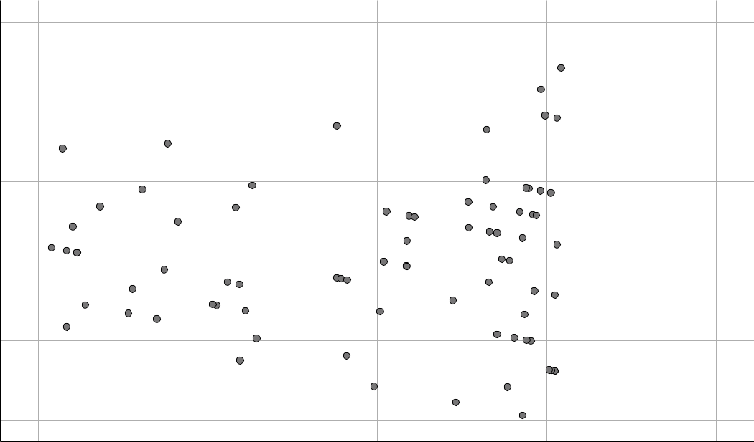

 | 3.00000
 | 2.00000
Residual | 1.00000
Standardized
 | .00000

- 1.00000

- 2.00000

-2.00000 -1.00000 .00000 1.00000

Standardized Predicted Value

REGRESSION

2

2.00000

Page 8

/DESCRIPTIVES MEAN STDDEV CORR SIG N

/MISSING LISTWISE

/STATISTICS COEFF OUTS CI(95) BCOV R ANOVA COLLIN TOL /CRITERIA=PIN(.05) POUT(.10) /NOORIGIN

/DEPENDENT TotalLanguagescores19QPre_regandReganalysis

/METHOD=ENTER Deprivedenviroments_v2Chaoticenviroment_v2Poolivingcondit ions_v2

LowSESconditions_v2Timespentinschools /SCATTERPLOT=(*ZRESID ,*ZPRED)

/RESIDUALS HISTOGRAM(ZRESID) NORMPROB(ZRESID)

/SAVE ZPRED COOK LEVER ZRESID.

Regression

Descriptive Statistics

 | Mean | Std. Deviation |  | N
Total Language scores | 17.99 | 3 | .301 | 7 8
19Q Pre-reg and Reg
analysis
Deprivedenviroments_v2 | . 63 |  | .486 | 7 8
Chaoticenviroment_v2 | . 27 |  | .446 | 7 8
Poorlivingconditions_v2 | . 46 |  | .502 | 7 8
LowSESconditions_v2 | . 47 |  | .503 | 7 8
Time spent in schools | 46.68 | 37 | .467 | 7 8

Page 9

Correlations

 |  | Total
 |  | Language
 |  | scores 19Q
 |  | Pre-reg and | Deprivedenvir | Chaoticenviro
 |  | Reg analysis | oments_v2 | ment_v2
Pearson Correlation | Total Language scores | 1.000 | .312 | -.253
 | 19Q Pre-reg and Reg
 | analysis
 | Deprivedenviroments_v2 | .312 | 1.000 | -.789
 | Chaoticenviroment_v2 | -.253 | -.789 | 1.000
 | Poorlivingconditions_v2 | .043 | .180 | -.214
 | LowSESconditions_v2 | -.067 | -.013 | .118
 | Time spent in schools | -.185 | -.126 | .222
Sig. (1-tailed) | Total Language scores | . | .003 | .013
 | 19Q Pre-reg and Reg
 | analysis
 | Deprivedenviroments_v2 | .003 | . | .000
 | Chaoticenviroment_v2 | .013 | .000 | .
 | Poorlivingconditions_v2 | .355 | .057 | .030
 | LowSESconditions_v2 | .281 | .455 | .152
 | Time spent in schools | .053 | .137 | .025
N | Total Language scores | 7 8 | 7 8 | 7 8
 | 19Q Pre-reg and Reg
 | analysis
 | Deprivedenviroments_v2 | 7 8 | 7 8 | 7 8
 | Chaoticenviroment_v2 | 7 8 | 7 8 | 7 8
 | Poorlivingconditions_v2 | 7 8 | 7 8 | 7 8
 | LowSESconditions_v2 | 7 8 | 7 8 | 7 8
 | Time spent in schools | 7 8 | 7 8 | 7 8

Page 10

Correlations

 |  | Poorlivingcondi | LowSESconditio | Time spent in
 |  | tions_v2 | ns_v2 | schools
Pearson Correlation | Total Language scores | .043 | -.067 | -.185
 | 19Q Pre-reg and Reg
 | analysis
 | Deprivedenviroments_v2 | .180 | -.013 | -.126
 | Chaoticenviroment_v2 | -.214 | .118 | .222
 | Poorlivingconditions_v2 | 1.000 | -.879 | -.128
 | LowSESconditions_v2 | -.879 | 1.000 | .054
 | Time spent in schools | -.128 | .054 | 1.000
Sig. (1-tailed) | Total Language scores | .355 | .281 | .053
 | 19Q Pre-reg and Reg
 | analysis
 | Deprivedenviroments_v2 | .057 | .455 | .137
 | Chaoticenviroment_v2 | .030 | .152 | .025
 | Poorlivingconditions_v2 | . | .000 | .132
 | LowSESconditions_v2 | .000 | . | .320
 | Time spent in schools | .132 | .320 | .
N | Total Language scores | 7 8 | 7 8 | 7 8
 | 19Q Pre-reg and Reg
 | analysis
 | Deprivedenviroments_v2 | 7 8 | 7 8 | 7 8
 | Chaoticenviroment_v2 | 7 8 | 7 8 | 7 8
 | Poorlivingconditions_v2 | 7 8 | 7 8 | 7 8
 | LowSESconditions_v2 | 7 8 | 7 8 | 7 8
 | Time spent in schools | 7 8 | 7 8 | 7 8

Variables Entered/Removed ª

 | Variables | Variables
Model | Entered | Removed | Method
1 | Time spent | . | Enter
 | in schools,
 | LowSEScondit
 | ions_v2,
 | Deprivedenvi
 | roments_v2,
 | Chaoticenviro
 | ment_v2,
 | Poorlivingcon
 | ditions_v2^{b}

- Dependent Variable: Total Language scores 19Q Pre-reg and Reg analysis

- All requested variables entered.

Page 11

Model Summary ^{b}

 |  |  | Adjusted R | Std. Error of
Model | R | R Square | Square | the Estimate
1 | . 394 ª | .155 | .096 | 3.138

- Predictors: (Constant), Time spent in schools, LowSESconditions_v2, Deprivedenviroments_v2, Chaoticenviroment_v2, Poorlivingconditions_v2

- Dependent Variable: Total Language scores 19Q Pre-reg and Reg analysis

ANOVAª

 |  | Sum of
Model |  | Squares | df | Mean Square |  | F | Sig.
1 | Regression | 130.114 | 5 | 26 | .023 | 2.643 | . 030 ^{b}
 | Residual | 708.873 | 7 2 | 9 | .845
 | Total | 838.987 | 7 7

- Dependent Variable: Total Language scores 19Q Pre-reg and Reg analysis

- Predictors: (Constant), Time spent in schools, LowSESconditions_v2, Deprivedenviroments_v2, Chaoticenviroment_v2, Poorlivingconditions_v2

Coefficientsª

 |  |  |  |  |  | Standardized
 |  | Unstandardized Coefficients |  |  |  | Coefficients
Model |  | B |  |  | Std. Error | Beta |  | t
1 | (Constant) | 19 | .311 |  | 1.692 |  | 11 | .414
 | Deprivedenviroments_v2 | 2 | .875 |  | 1.269 | .424 | 2 | .265
 | Chaoticenviroment_v2 |  | .613 |  | 1.359 | .083 |  | .451
 | Poorlivingconditions_v2 | -2.693 |  |  | 1.627 | -.409 | -1.6 |  | 5 5
 | LowSESconditions_v2 | -2.768 |  |  | 1.606 | -.421 | -1.7 |  | 2 4
 | Time spent in schools | -.016 |  |  | .010 | -.180 | -1.5 |  | 9 1

Coefficientsª

 |  |  |  |  |  |  | Collinearity
 |  |  | 95.0% Confidence Interval for B |  |  |  | Statistics
Model |  | Sig. | Lower Bound |  | Upper Bound |  | Tolerance
1 | (Constant) | .000 | 15.938 |  | 22 | .683
 | Deprivedenviroments_v2 | .027 | .345 |  | 5 | .404 | .336
 | Chaoticenviroment_v2 | .653 | -2.096 |  | 3 | .322 | .347
 | Poorlivingconditions_v2 | .102 | -5.937 |  |  | .550 | .192
 | LowSESconditions_v2 | .089 | -5.969 |  |  | .433 | .196
 | Time spent in schools | .116 | -.036 |  |  | .004 | .921

Page 12

Coefficientsª

Collinearity
Statistics

Model ^{VIF}
- (Constant)

Deprivedenviroments_v22 .980

Chaoticenviroment_v2 | 2.879
Poorlivingconditions_v2 | 5.212
LowSESconditions_v2 | 5.094
Time spent in schools | 1.086

a. Dependent Variable: Total Language scores 19Q Pre-reg and Reg analysis

Coefficient Correlations ª

 |  |  | Time spent in |  | LowSESconditio | Deprivedenvir
Model |  |  | schools |  | ns_v2 | oments_v2
1 | Correlations | Time spent in schools | 1.000 |  | .131 | -.121
 |  | LowSESconditions_v2 | .131 |  | 1.000 | -.323
 |  | Deprivedenviroments_v2 | -.121 |  | -.323 | 1.000
 |  | Chaoticenviroment_v2 | -.209 |  | -.177 | .784
 |  | Poorlivingconditions_v2 | .156 |  | .893 | -.299
 | Covariances | Time spent in schools | 9.888E-5 |  | .002 | -.002
 |  | LowSESconditions_v2 | .002 |  | 2.579 | -.658
 |  | Deprivedenviroments_v2 | -.002 |  | -.658 | 1.610
 |  | Chaoticenviroment_v2 | -.003 |  | -.386 | 1.352
 |  | Poorlivingconditions_v2 | .003 |  | 2.333 | -.618
 |  | Coefficient Correlations ª
 |  |  | Chaoticenviro |  | Poorlivingcondi
Model |  |  | ment_v2 |  | tions_v2
1 | Correlations | Time spent in schools | -.209 |  | .156
 |  | LowSESconditions_v2 | -.177 |  | .893
 |  | Deprivedenviroments_v2 | .784 |  | -.299
 |  | Chaoticenviroment_v2 | 1.000 |  | -.114
 |  | Poorlivingconditions_v2 | -.114 |  | 1.000
 | Covariances | Time spent in schools | -.003 |  | .003
 |  | LowSESconditions_v2 | -.386 |  | 2.333
 |  | Deprivedenviroments_v2 | 1.352 |  | -.618
 |  | Chaoticenviroment_v2 | 1.847 |  | -.251
 |  | Poorlivingconditions_v2 | -.251 |  | 2.647

Page 13

a. Dependent Variable: Total Language scores 19Q Pre-reg and Reg analysis

Collinearity Diagnostics ª

 |  |  |  |  |  | Variance Proportions
 |  |  | Condition |  |  | Deprivedenvir |  | Chaoticenviro
Model | Dimension | Eigenvalue | Index |  | (Constant) | oments_v2 |  | ment_v2
1 | 1 | 3.575 | 1 | .000 | .00 | .01 |  | .01
 | 2 | 1.176 | 1 | .744 | .00 | .02 |  | .08
 | 3 | .851 | 2 | .050 | .00 | .02 |  | .09
 | 4 | .305 | 3 | .425 | .01 | .00 |  | .07
 | 5 | .065 | 7 | .409 | .07 | .94 |  | .72
 | 6 | .028 | 11 | .322 | .92 | .01 |  | .04

Collinearity Diagnostics ª

 |  | Variance Proportions
 |  | Poorlivingcondi | LowSESconditio | Time spent in
Model | Dimension | tions_v2 | ns_v2 | schools
1 | 1 | .00 | .00 | .02
 | 2 | .03 | .02 | .00
 | 3 | .03 | .04 | .00
 | 4 | .01 | .02 | .90
 | 5 | .16 | .19 | .01
 | 6 | .77 | .73 | .07

a. Dependent Variable: Total Language scores 19Q Pre-reg and Reg analysis

Page 14

Residuals Statisticsª

 | Minimum | Maximum |  | Mean | Std. Deviation | N
Predicted Value | 15.49 | 19.40 |  | 17.99 | 1.300 | 7 8
Std. Predicted Value | -1.920 | 1 | .085 | .000 | 1.000 | 7 8
Standard Error of | .569 | 1 | .626 | .827 | .271 | 7 8
Predicted Value
Adjusted Predicted Value | 15.21 | 20.16 |  | 17.99 | 1.329 | 7 8
Residual | -6.101 | 7 | .603 | .000 | 3.034 | 7 8
Std. Residual | -1.944 | 2 | .423 | .000 | .967 | 7 8
Stud. Residual | -1.987 | 2 | .480 | -.001 | .999 | 7 8
Deleted Residual | -6.374 | 7 | .963 | -.007 | 3.246 | 7 8
Stud. Deleted Residual | -2.030 | 2 | .575 | .001 | 1.011 | 7 8
Mahal. Distance | 1.546 | 19 | .695 | 4.936 | 4.408 | 7 8
Cook's Distance | .000 |  | .086 | .012 | .016 | 7 8
Centered Leverage Value | .020 |  | .256 | .064 | .057 | 7 8

a. Dependent Variable: Total Language scores 19Q Pre-reg and Reg analysis

Charts

Histogram

Dependent Variable: Total Language scores 19Q Pre-reg and Reg analysis
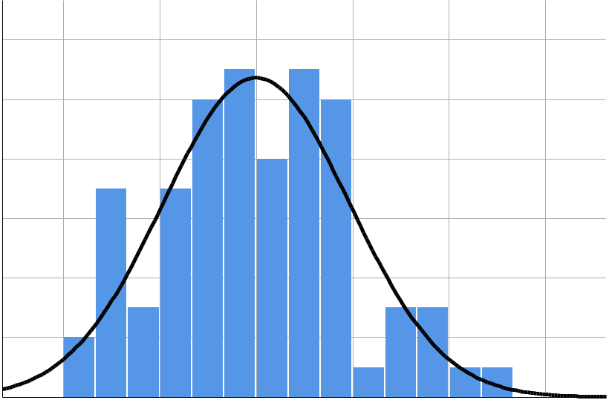

 |  |  |  |  |  | Mean = 1.51E-15
 | 1 2 |  |  |  |  | Std. Dev. = 0 . 9 6 7
 |  |  |  |  |  | N =78
 | 1 0
Frequency | 8
 | 6
 | 4
 | 2
 | 0
 | - 2 | - 1 | 0 | 1 | 2 | 3

Regression Standardized Residual

Page 15

Normal P-P Plot of Regression Standardized Residual

Dependent Variable: Total Language scores 19Q Pre-reg and Reg analysis
1 . 0

0 . 8

Expected Cum Prob

0 . 6

0 . 4

0 . 2

0 . 0
0.0 0.2 0.4 0.6 0.8 1.0

Observed Cum Prob

Regression Standardized Residual

Scatterplot

Dependent Variable: Total Language scores 19Q Pre-reg and Reg analysis
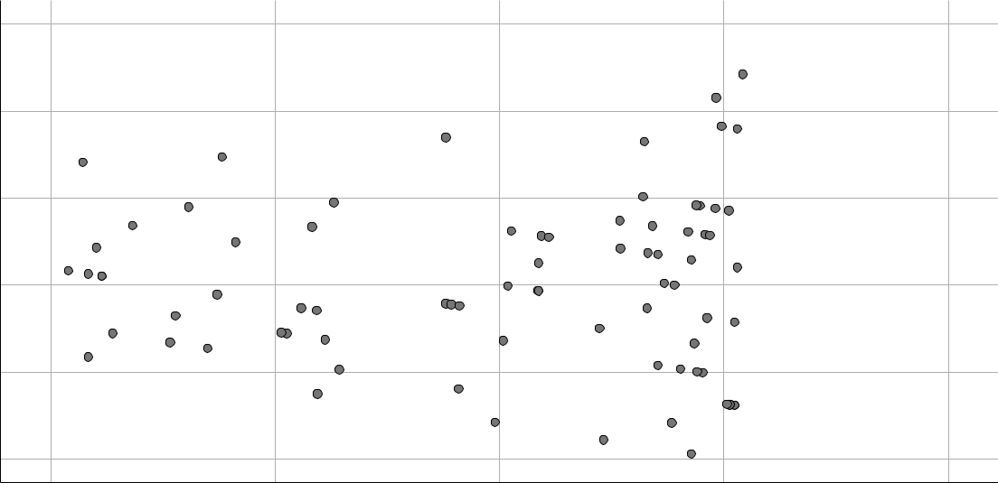

3

2

1

0

- 1

- 2

-2 -1 0 1 2

Regression Standardized Predicted Value

Your license will expire in 22 days.

Page 16

