Deep neck infections: a review of 124 patients and long-term Outcome

Deep neck space infections (DNI) are one of the most common head and neck surgery emergencies. They are defined as bacterial infections within the neck localized in the spaces comprised between the layer of the deep cervical fascia. (superficial, middle (visceral), and deep layers).
Even if the use of large-spectrum antibiotics and the improvement of dental hygiene seems to have diminished the cases compared to the past, some reports show that their incidence might be rising (Berger 2003, Lau 2014) and currently their incidence is reported to be between 9 and15/100,000 yearly (boscolo rizzo).
Improved diagnostic techniques and early hospital-based management have diminished the complication incidence of DNI, which include potentially life-threatening morbidities such as mediastinitis, laryngeal edema, pericarditis, jugular vein thrombosis, or arterial erosion. Management of DNI is still debated and can be based on prompt surgical drainage of pus collection when this is present, or medical treatment followed by surgical drainage if there is no adequate response (Plaza Mayor 2001).
Moreover, even if there are numerous studies on the management and causes of a large number of DNI cases (Supreet 2019, Bakir 2010) there are no reports focusing on long-term follow-up and potential long-term complications due to the infection or surgical intervention.
The aim of this study was to review our experience in the surgical management of DNI, assess the possible characteristics that can lead to a more severe presentation or prognosis, and assess the frequency and impact of long-term sequelae.

MATERIALS AND METHODS

Study design
The study design was a hybrid design with two components: a retrospective chart review and a prospective survey.

Retrospective review
We reviewed the records of 124 patients operated at a tertiary center (San Giovanni Bosco Hospital, Turin, Italy) between 2008 and 2020, assessing demography, site of infection, initial presentation, etiology, comorbidities and length of stay.
We excluded patients with peritonsillar abscess and patients who were managed conservatively.

Prospective survey
We contacted patients to complete the information on long-term outcome.
Patients who were available for the interview were called and interviewed on recurrence of the abscess.
Patients who reported neurologic diseases, orthopedic interventions, or trauma were not interviewed on the presence of dysphagia or shoulder disabilities. If there was not any other known cause of dysphagia , the Eating Assessment Tool (EAT-10) (Belafski 2008) was administered .
This index has shown consistency and reliability and dysphagia was defined as an EAT-10 score of 3 or higher.

Data analysis
Acquired data included demographic characteristics, symptoms, localization of the abscess, etiology, result of microbiological culture, surgical approach and need for surgical revision, need for tracheostomy or early intubation, complications, comorbidities, mortality and duration of hospitalization.

RESULTS

Retrospective review

There were 40 females (34%) and 84 males (67%). Patients ranged in age from 17 to 89 years, with an average of 49 years (Table I). The mean in-hospital length of stay was 11.3 days ( SD 5.7; range 3-27).
Of the 124 patients, 52 (42 %) were current smokers, 9 (8 %) were intravenous drug users and 19 (15 %) were diabetic (Table 1)

Table 1
Demographics of patients presenting with a deep neck space infection

Patients demographics (%) | Patients*
Female | 40 (34)
Male | 84 (67)
Smoker | 52(42)
Diabetic | 19(15)
Intravenous drug use | 9 (8)
Age (range, years) | 17--89
Length of hospital stay (range, days) | 3--27
Clinical presentation
Dyspnea | 36(29)
Odynophagia | 70 (56)
Dysphonia | 28 (23)
Airway Edema | 48 (39)

*Total n=124

Fascial space incidence

Etiology and Culture
There were 8 different microorganisms isolated and identified on culture. The majority of cases were unknown because the culture did not show any growth or was not done/available (Figure1).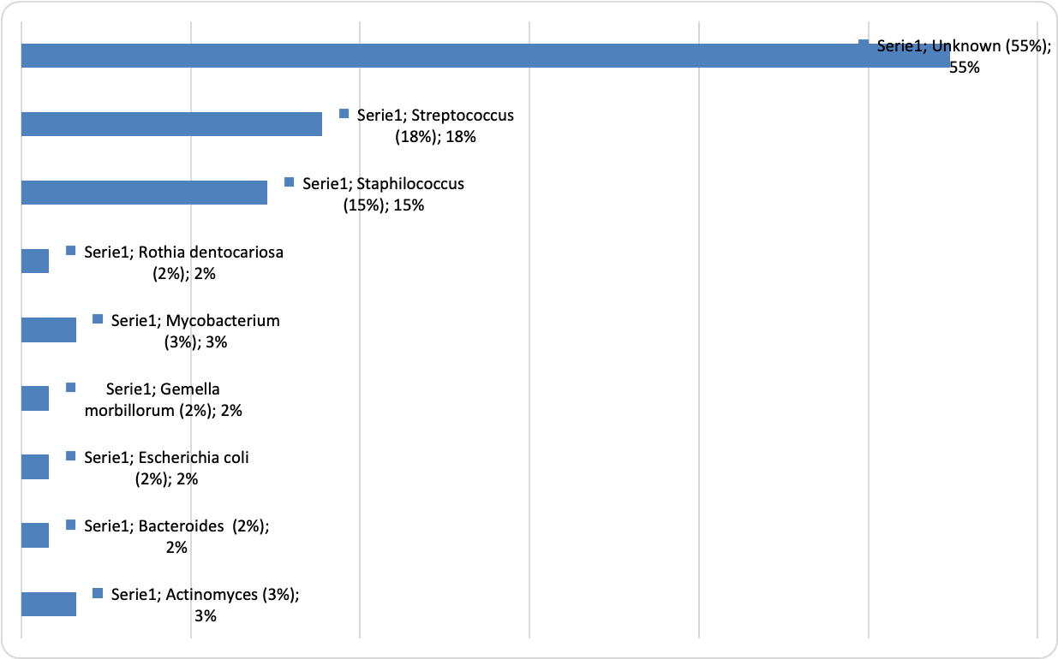
Figure 1: Microorganisms

Cause
Was possible to identify a cause in 47% of cases. Identified causes are depicted in figure 2.
Under the label other we included thyroiditis (2 cases), actynomicosis (1 case, epiglottitis (2 cases), bacterial pneumoniae (1 case) , metal plate infection ( 1 case), sphenoid infection (1 case) .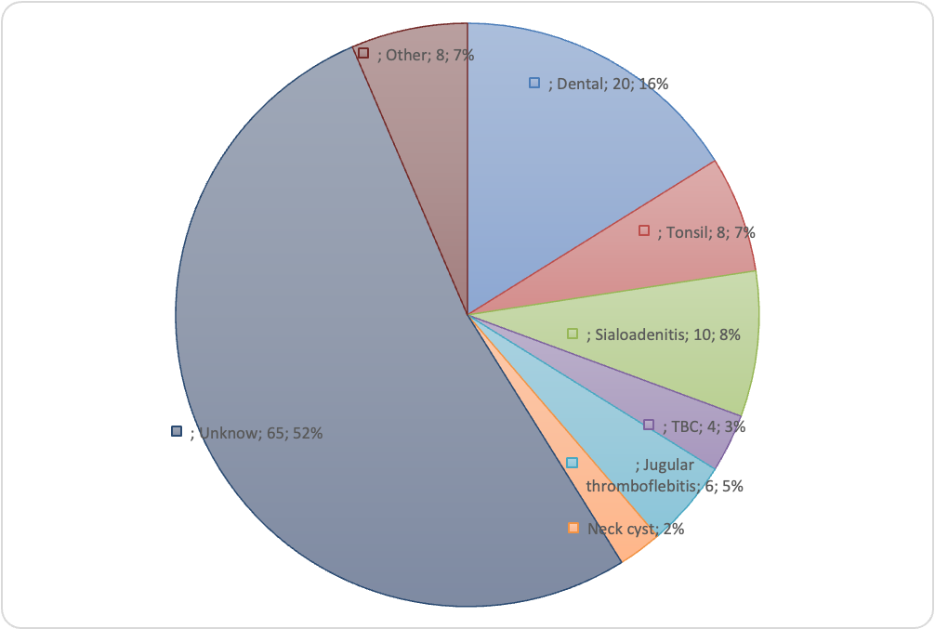
Figure 2: causes identified.

Symptoms

Odinophagia was the most common symptom, present overall in 70 (56% ) patients. Thirty-six patients (29%) patients complained of dyspnea and 28 (23%) patients presented dysphonia. Forty-eight patients (39%) had airway edema on fiber optic examination.

When we considered the different subsites affected odynophagia was the most common symptom in patients with masticatory space involvement (92%), dyspnea was most common in patients with parapharyngeal space involvement, whereas dysphonia was common in patients with prevertebral space involvement (table 2).

Table 2
Association of symptoms with fascial space involved
 |  | Dyspnea | Odynophagia | Dysphonia | Airway Edema
Preepiglottic | 20 | 20% | 30% | 20% | 25%
Submandibular | 48 | 33% | 79% | 25% | 21%
Parapharyngeal | 62 | 48% | 71% | 39% | 32%
Prevertebral | 18 | 22% | 78% | 56% | 28%
Parotid | 14 | 29% | 71% | 14% | 14%
Masticatory | 24 | 42% | 92% | 33% | 25%
Carotid | 46 | 39% | 74% | 39% | 26%
Pretracheal | 28 | 36% | 50% | 14% | 18%
Visceral | 34 | 26% | 59% | 35% | 38%

Complications
Eleven patients had mediastinitis, 3 patients had internal jugular vein thrombosis, one patient had a pulmonary embolism, one patient had transverse sinus thrombosis, and one patient had facial nerve paralysis. The overall mortality rate was 0,8% due to a patient with an extended parapharyngeal who died because of ischemic brain damage due to airway obstruction before the urgent tracheostomy.
Revision surgery was required in 32 % of cases (40 patients).
Acute airway management was required in 26% of patients. In particular, tracheostomy was required in 10 % of cases ( 12 patients) and early intubation was required in 16% of cases (20 patients).

In hospital stay and multiple fascial space involvement

odds ratio calculated by logistic regression model: for more than two involved neck spaces

Prospective survey
75 patients out of 124 were interviewed telephonically.
49 patients were lost to follow-up because they were untraceable or declared dead.
Among the 75 patients interviewed, 41 patients were excluded from the interview because they had other diseases that may be associated with dysphagia or shoulder disability (Orthopedic interventions, neurologic diseases, or trauma). In terms of long term dysphagia, 6 total patients (17%) out of 34 reported an EAT-10 score of 3 or greater, with an average EAT-10 score of 4.9 (Table 3).

A summary of EAT-10 results are presented in Table 3.

 | EAT-10 > 3 | EAT-10 < 3
Number of patients | 6/34 (18%) | 28/34 (826%)
Females | 75% | 39%
Males | 25% | 61%
Mean age (years) | 54 (± 19.23) | 56.7 (± 13.93)
Duration of hospitalisation (days) | 13 (range 7-17) | 7 (range 4-10)
Oral endotracheal intubation (n. patients) | 4/34 (12%) | 6/34 (18%)
Tracheostomy | 8/34 (24%) | 1/34 (3%)
Presenting symptoms
Odynophagia | 22 (65%) | 17 (34%)
Dyspnea | 8/34 (24%) | 10/34 (29%)
Dysphonia | 7/34 (20%) | 5/34 (15%)
Table 3 Epidemiologic, antropometric and clinical data of EAT-10+ and EAT-10− groups

